So you’re thinking about going abroad with Mr. Mainland…..

Hello, high schoolers! If you’re spending your sparse free time reading this (or he’s making you read it in class), then Mr. Mainland has most likely talked up his one-of-a-kind trips to Europe. If you’re on the fence, or you’re thinking ‘maybe but teachers are weird’, I’m here with a biased (yet experienced!) opinion as to why you should definitely hang out with your favorite social studies teacher for a week or two in a foreign country. Here are a few key points to consider when persuading your parents to let you go abroad without them.

- Although it is expensive, Mr. Mainland makes sure you get all kinds of cultural experience you probably wouldn’t get if your parents took you on an all-inclusive, all-touristy trip to the same place. I’m not sure how, but he knows all the back-alley cafes and sites that as an American tourist you probably wouldn’t go near.
- He knows his stuff. Mr. Mainland is really good at pretending like he knows everything, but he’s also really good at actually having some kind of answer to anything you ask (whether witty or smart-assy depends on the question). If you have any kind of untraveled questions like “What’s a Bobbie?” or “Where does the croissant come from?”, your questions will be answered.
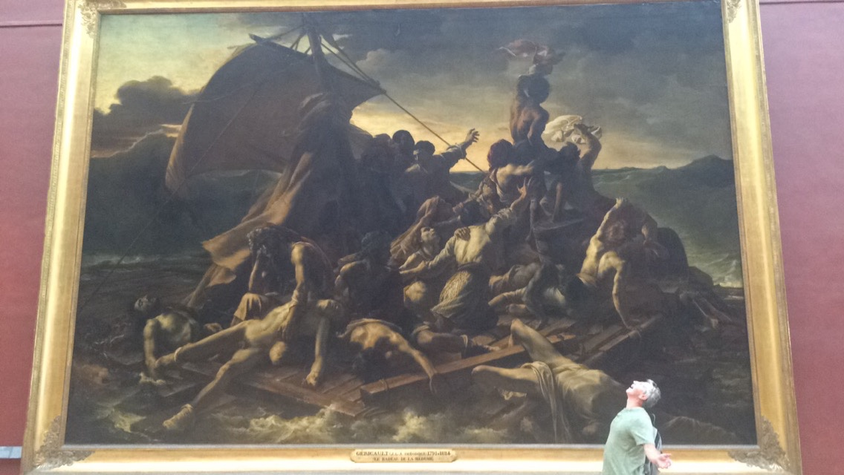

- You’ve probably had Mr. Mainland in AP Euro, Current World Affairs, World History, or for some crazy reason American Government, and whether or not you pass(ed) his class doesn’t matter if you want to go on this trip (but if you do know some historical stuff, you get to be a show off). I sure didn’t do great on any of his too-specific scantrons and especially could have done way better on the AP Euro test, but maybe the reason you can’t pass social studies is because you aren’t seeing things well out of a textbook or on one of those James Burke BBC documentaries that Mr. Mainland loves so much. Seeing history where it happens can really help solidify why it’s such an important subject to study.
- On that note, you don’t have to like history to travel with Mr. Mainland. A lot of the kids that I traveled with for some reason really liked math and science, but still got a lot out of Mr. Mainland’s many rants about architecture and history.
- It’s an experience of a lifetime. You’re gonna do things and see things that you never thought you would. You’ll get really close with a bunch of kids you probably don’t know very well. You’ll eat a lot of awesome food. And when it’s all over, and you’re returning to DIA, you’ll regret agreeing to get in that taxi that took you to the train station that took you to the airport that took you to another airport that took you to another airport that took you back stateside. I promise you will.

If I haven’t persuaded you yet, just keep in mind, you get to travel without your parents. And if THAT doesn’t persuade you, then you might still be a freshman (and for that I send my condolences.)

If I have persuaded you, here’s what to expect:

- You might get stuck in an airport or train station. Like the Iceland airport for something like 8 hours. Yeah, you can say you’ve been to Iceland, but there are cooler airports than the Reykjavik airport. Also their food is weird. Or you’ll get stuck in the Eurostar train station in Paris. Because your train hit a cow. And trust me, your train will show up with cow blood on it. But you’ll be entertained while you wait, I swear.

2. You get to call Mr. Mainland by his first name. Unless you’re like me and that feels super weird, you can call him ‘Mainland’ or ‘Mr. Mainland’ instead of Keith.

3. Your feet will hurt more than you think they will. Because Mr. Mainland makes you speed walk. A lot.

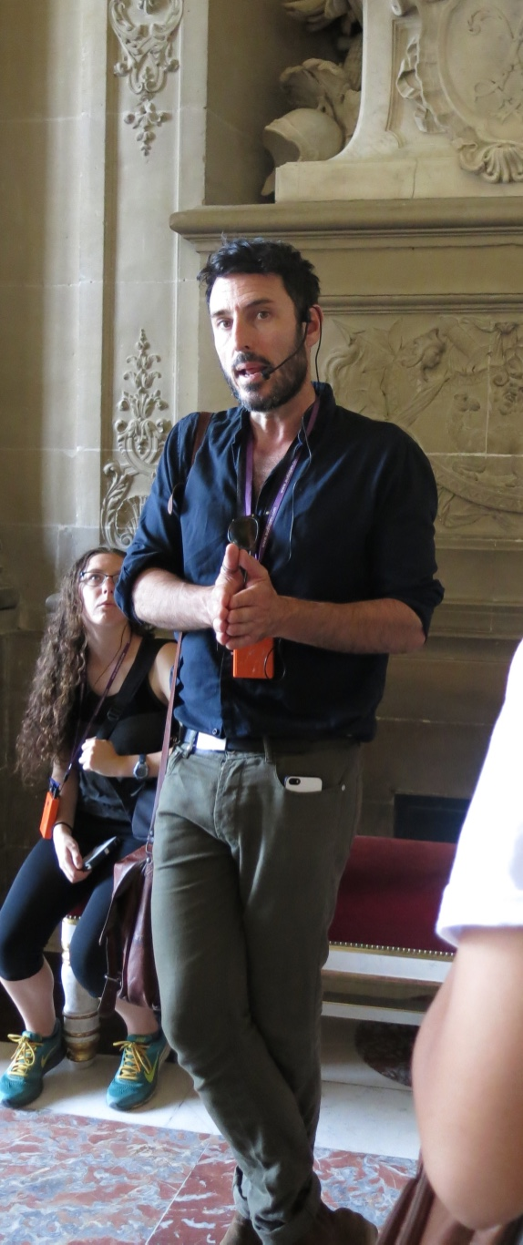
4. If you choose to, you’ll get to know Mr. Mainland and the other kids really well. I ate breakfast almost all ten days of my trip with Mr. Mainland. I also sat next to him on a six hour flight from Denver to Reykjavik. I promise, despite him being your teacher, he can be a pretty cool dude!

5. You’ll get to try alcohol for the ‘first’ time! (If your parents give you permission/if you’re of age.) The only con to this is Mr. Mainland knows if it really is your first time. (He sure knew it was mine.)

6. Odds are, you’ll have some really good-looking European tour guides.
7. You’ll have the opportunity to hang out and play games like Telephone Pictionary with everybody, in which case you could see really amusing drawings drawn by your history teacher.

8. Tell your parents not to worry, Mr. Mainland will take good care of you. But actually, he handles all the rude and drunk Europeans that don’t enjoy the company of us amazing American tourists, or the creepy ones that might follow you around. He also speaks a bit of French, or at least enough to get you by. Oh, side note, he’s going to make you navigate the public transportation. So study up ahead of time.
9. There will be some early morning and long nights. But get over it. You’re in freaking Europe.

10. It’s one of the best ways to end a school year. Especially if you’re a senior, although I guarantee the kids that came along on my trip that weren’t seniors still had a wicked time.

If you’ve committed to going on this trip, just know I’m 10/10 envious. Whether you’ve never been out of the country or this is your 27th time visiting Europe, I promise it’ll be worth it. You might get sick of your roommates and tired of eating croissants every day for breakfast (though you probably won’t), but it’s a phenomenal way to travel. Mr. Mainland knows Europe and makes sure you get to see everything worth seeing. I’d kill to tag along on this year’s trip (although I’d probably say I’m happier not being high school), but since I can’t, I’ll most likely plan on sending Mr. Mainland an email every time I plan to travel so he can tell me where to go and where not to go.

Mallory Prentiss
Class of 2015

