WORLD HISTORY SECTION II
Question 1 (Document-Based Question)
Suggested Reading period: 15 minutes
Suggested writing time: 45 minutes

Directions: Question 1 is based on the accompanying documents. The documents have been edited for the purpose of this exercise.
In your response, you should do the following:
· Respond to the prompt with a historically defensive thesis or claim that establishes a line of reasoning.
· Describe a broader historical context relevant to the prompt.
· Support an argument in response to the prompt using at least six documents.
· Use at least one additional piece of specific historical evidence (beyond
that found in the documents) relevant to an argument in the prompt.
· For at least three documents, explain how or why the documents point of view, purpose, historical situation, and/or audience is relevant to an argument.
· Use evidence to corroborate, qualify, or modify an argument that addresses the prompt.

- Analyze the responses to the spread of COVID-19.

Historical background: An outbreak of respiratory disease caused by a new coronavirus, abbreviated as COVID-19, was first detected in China in December 2019. The disease is now present in more than 100 locations internationally.

Note: The map below shows countries with confirmed COVID-19 cases and is provided as a reference.

The map is NOT one of the seven documents. The documents begin on the next page.
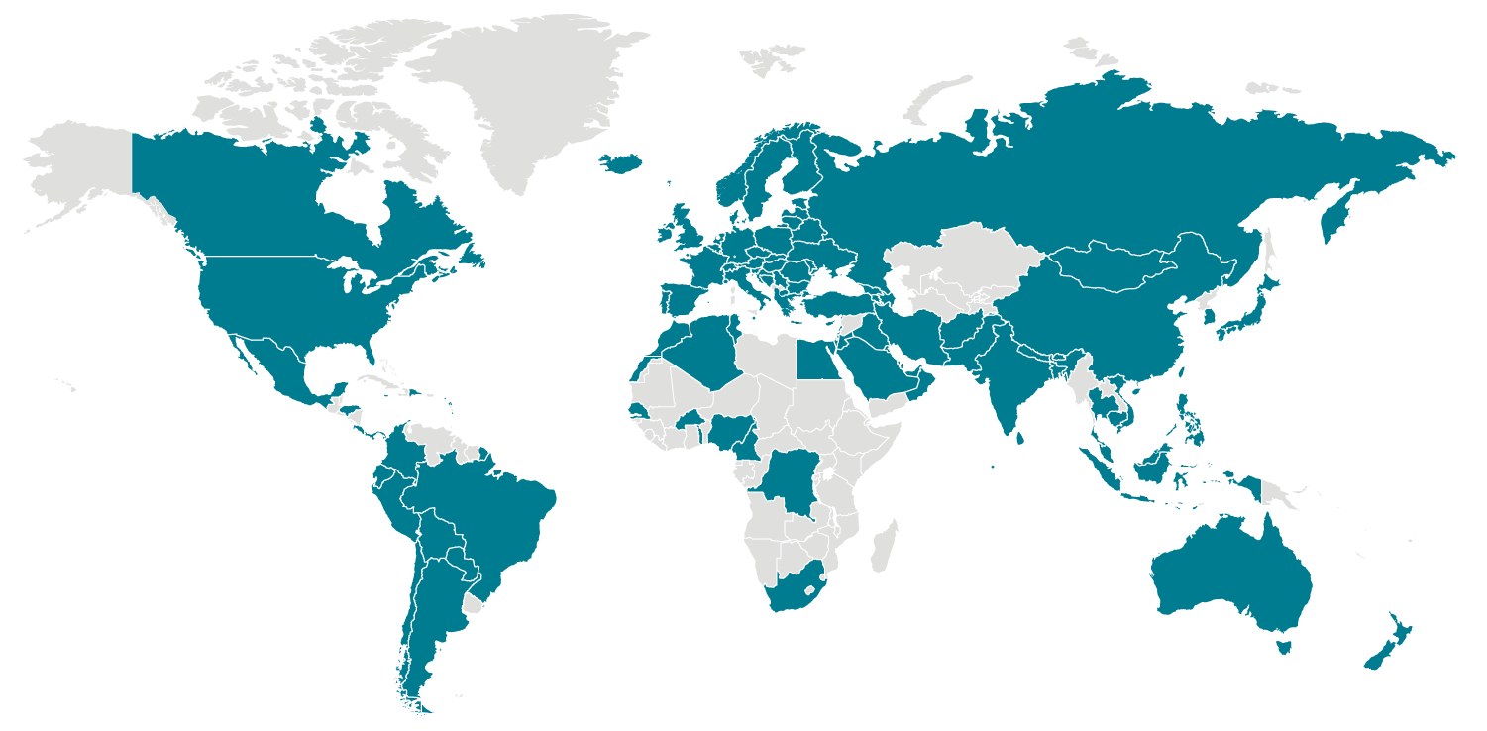

Document 1

Source: Forbes Magazine (online) March 13 2020. Article by staff writer Isabel Togoh.

Several elite soccer matches across Europe have been halted, with governing bodies UEFA (Union of European Football Associations) and England’s Football Association suspending matches in major leagues until at least next month after a handful of teams were affected by Covid-19 infections.
European soccer’s governing body, UEFA, said its Champions League and Europa League Matches slated for next week were postponed.
UEFA said in a statement: “This includes the remaining UEFA Champions League, Round of 16 second leg matches scheduled on 17 and 18 March 2020; all UEFA Europa League, Round of 16 second leg matches scheduled on 19 March 2020; all UEFA Youth League, quarter-final matches scheduled on 17 and 18 March 2020.”
Matches in England’s top-tier Premier League, EFL (English Football League), FA Women’s Super League and FA Women’s Championship have also been postponed until April 3 after seven teams were affected by players or managers who are infected with Covid-19.
Premier League chief executive Richard Masters said in a statement: "In this unprecedented situation, we are working closely with our clubs, Government, The FA and EFL and can reassure everyone the health and welfare of players, staff and supporters are our priority." Friday’s decisions follow a meeting of shareholders.
Arsenal manager Mikel Arteta and Chelsea player Callum Hudson-Odoi tested positive for Covid-19, while players across six teams: Arsenal, Chelsea, Leicester City, Bournemouth, Manchester City, Juventus and Real Madrid, are self-isolating.
Scotland’s soccer games have also been suspended until further notice.
England’s soccer governing body, the FA (Football Association), said in a statement: “The decision is being made purely on the number of cases requiring self-isolation and the impact on facilities.
“Given the steps being taken across clubs, there is no alternative but for today’s action. However, all parties are committed at this time to trying to complete this season’s domestic fixture programme and are liaising to establish appropriate options to do so.”
Clubs are encouraged to suspend “all non-essential activities” including player appearances, training ground visits and fan meetings, the statement said.
Leagues in Spain, Italy, Germany and other European nations have all suspended matches for the forseeable future

Document 2

Source: “I Stay Home Decree”, selected excerpts, Published by the Italian Prime Minister’s Office on March 10, 2020. The decree is to be enforced from March 10 to April 3.

1) All public gatherings are strictly banned in public places or places open to the public.
5) Whoever has a body temperature higher than 37.5 °C is “strongly recommended” to stay home.
6) Who is in quarantine must stay home.
7) Companies should facilitate their employees with vacations or work leaves.
9) All events – included cultural, recreational, sport, religious, and trade-fair events – are called off.
10) All activities in child-care centers, schools, and universities are called off.
11) All civil and religious ceremonies, funerals included, are called off.
14) At the weekend medium and big stores (such as shopping malls, supermarkets, and markets) will be closed.

Document 3

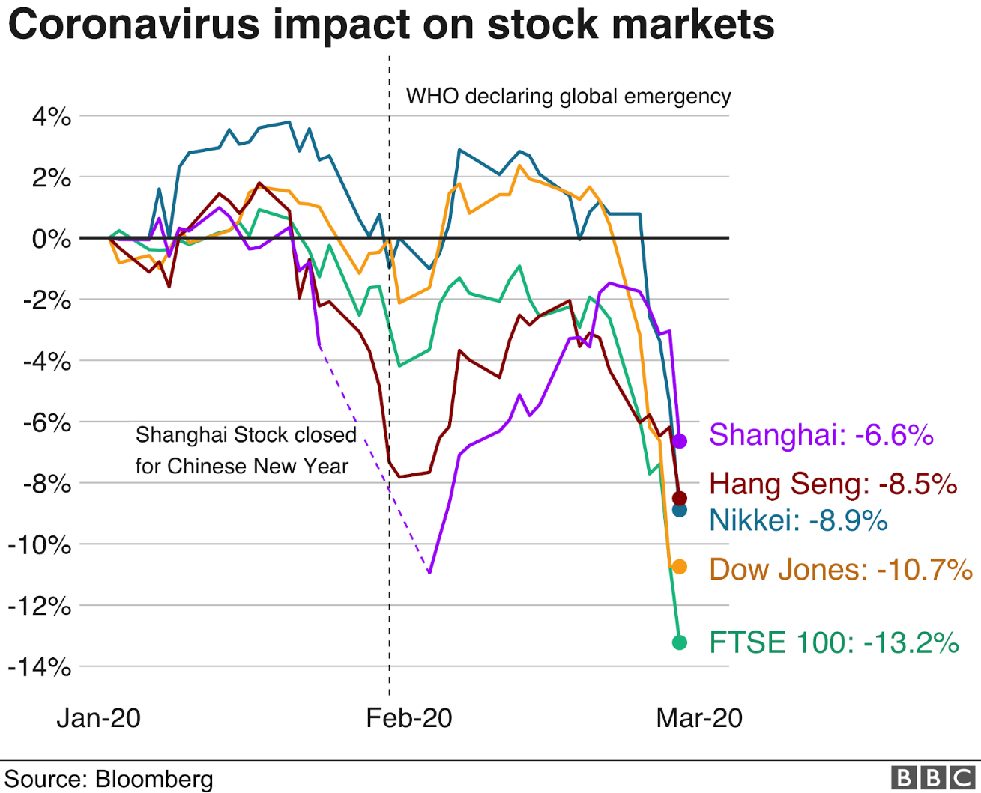

Document 4
Source: The Wuhan International Conference and Exhibition Center is converted into a hospital to receive patients infected with the novel coronavirus on Feb. 4
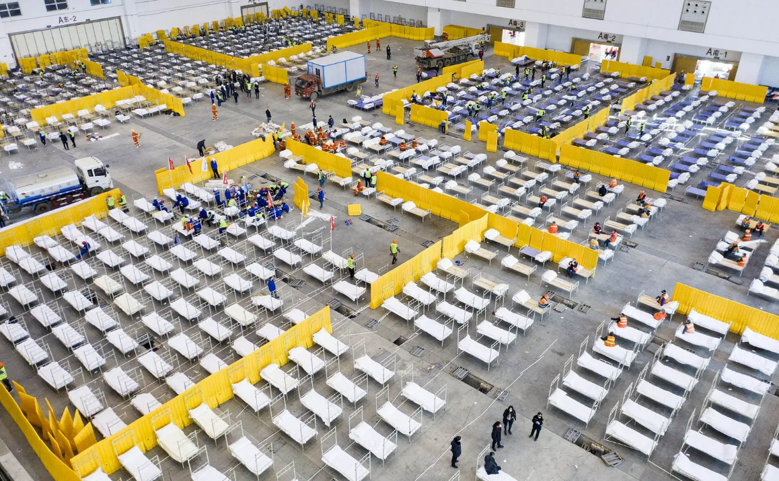
Photograph: Chine Nouvelle / SIPA / Shutterstock

Document 5

Source New York Times, By Katrin Bennhold and Melissa Eddy, March 11, 2020

- BERLIN — Chancellor Angela Merkel is on her way out and her power is waning, but in her typically low-key, no-nonsense manner, the German leader on Wednesday laid out some cold, hard facts on the coronavirus in a way that few other leaders have.
- Two in three Germans may become infected, Ms. Merkel said at a news conference that reverberated far beyond her country. There is no immunity now against the virus and no vaccine yet. It spreads exponentially, and the world now faces a pandemic.
- The most important thing, the chancellor said, is to slow down the spread of the coronavirus to win time for people to develop immunity, and to prevent the health care system from becoming overwhelmed.
- “We have to understand that many people will be infected,” Ms. Merkel said. “The consensus among experts is that 60 to 70 percent of the population will be infected as long as this remains the situation.”
- Ms. Merkel’s estimates were probably a worst-case scenario, though not wildly out of line with those of experts outside Germany.
- Her warning provided a stark contrast to the crimped pronouncements of many other world leaders, among them President Trump, who has mostly played down the contagion. In a televised address Wednesday night, Mr. Trump took a somber tone as he suspended travel from Europe, excluding the United Kingdom, for 30 days.
- But while the address was Mr. Trump’s most public acknowledgment of the severity of the crisis, he also criticized the European Union, saying it helped spread the virus to the United States by failing to take sufficient precautions of its own.

Document 6
Source: Editorial Cartoon, USA Today Network, March 6, 2020
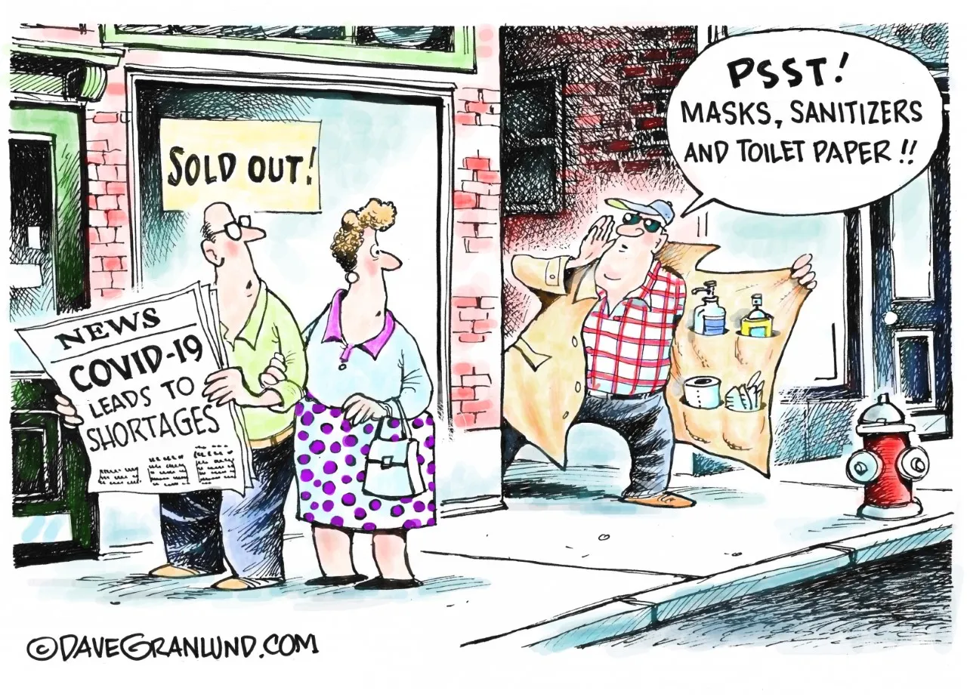
Document 7

Source: WHO Director-General's opening remarks at the media briefing on COVID-19, March 11, 2020

Good afternoon.

In the past two weeks, the number of cases of COVID-19 outside China has increased 13-fold, and the number of affected countries has tripled. There are now more than 118,000 cases in 114 countries and 4,291 people have lost their lives. …

WHO has been assessing this outbreak around the clock and we are deeply concerned both by the alarming levels of spread and severity, and by the alarming levels of inaction. We have therefore made the assessment that COVID-19 can be characterized as a pandemic. Pandemic is not a word to use lightly or carelessly. It is a word that, if misused, can cause unreasonable fear, or unjustified acceptance that the fight is over, leading to unnecessary suffering and death.
…
This is not just a public health crisis, it is a crisis that will touch every sector – so every sector and every individual must be involved in the fight. I have said from the beginning that countries must take a whole-of-government, whole-of-society approach, built around a comprehensive strategy to prevent infections, save lives and minimize impact.
…

Find, isolate, test and treat every case and trace every contact; Ready your hospitals; Protect and train your health workers. And let’s all look out for each other, because we need each other.

